**CAPSTONE PROJECT**

**ONLINE BUS TICKET BOOKING-JAVA FULL STACK**

**ENTITY-BOOKING**

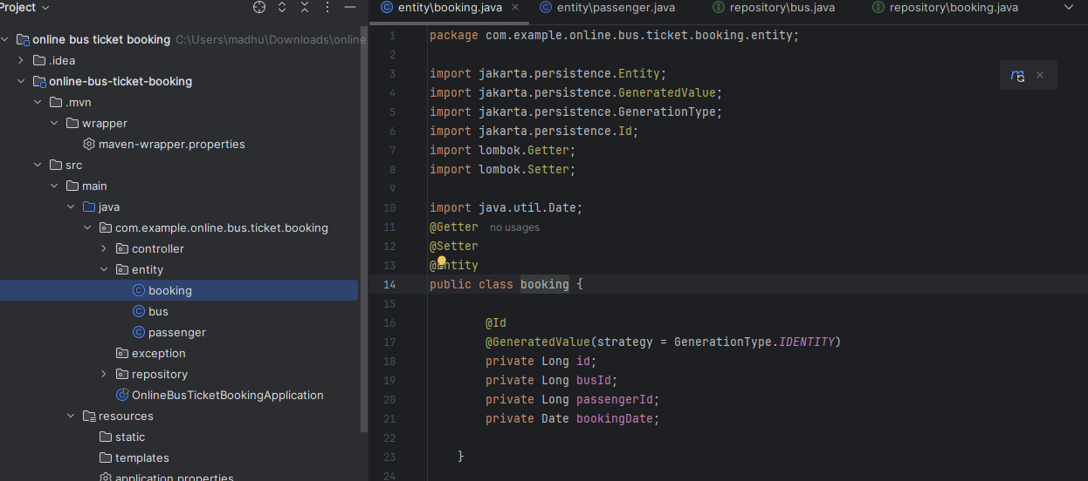

**ENTITY-BUS**

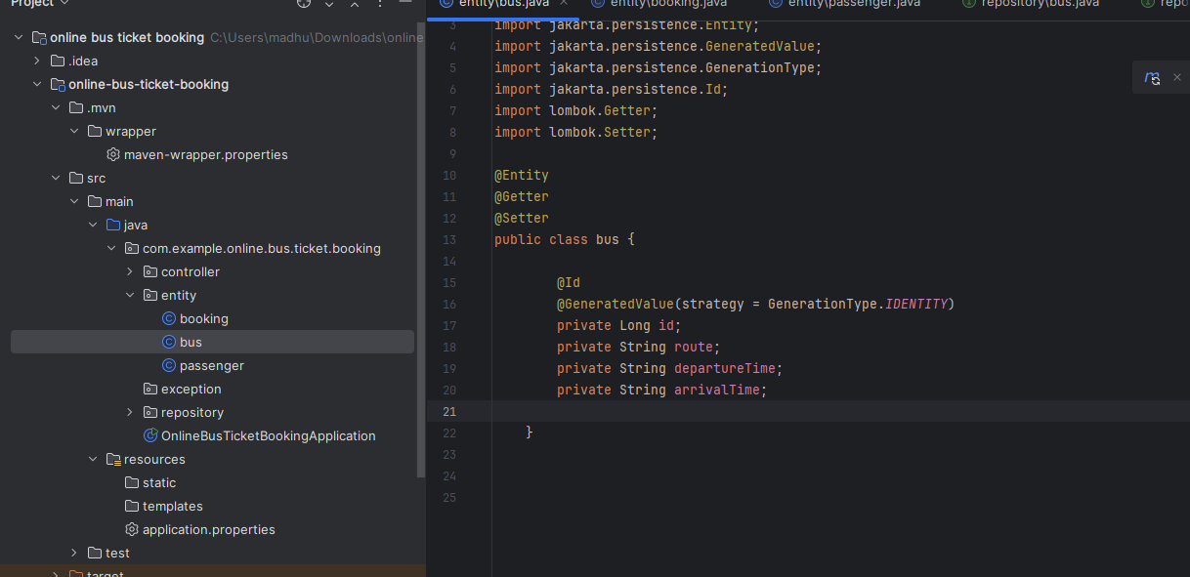

**ENTITY-PASSENGER**

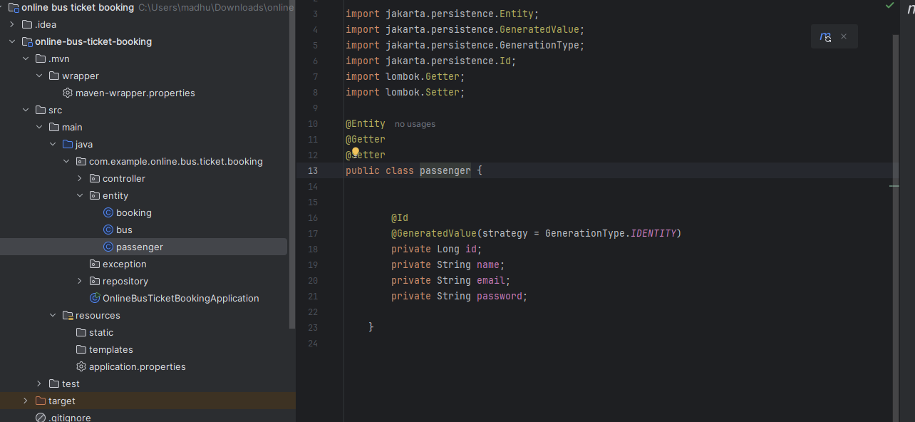

**CONTROLLER-BOOKING**

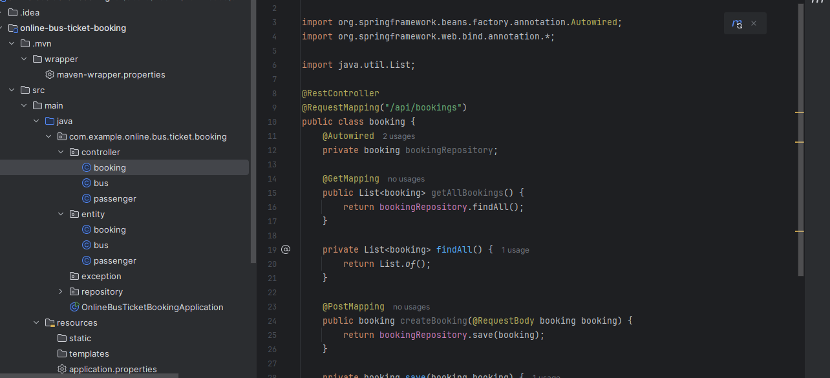

**CONTROLLER-BUS**

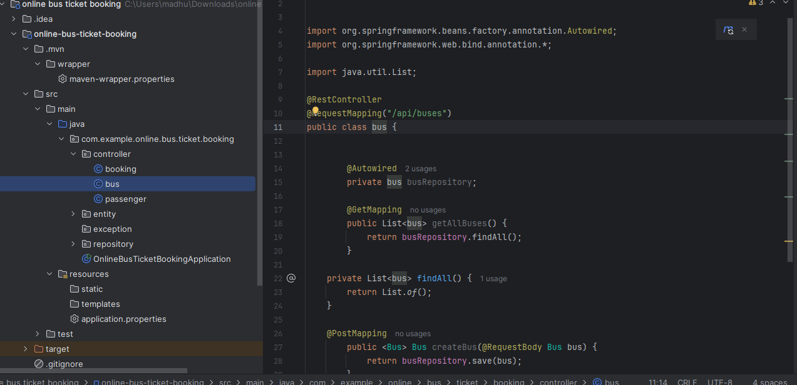

CONTROLLER-PASSENGER

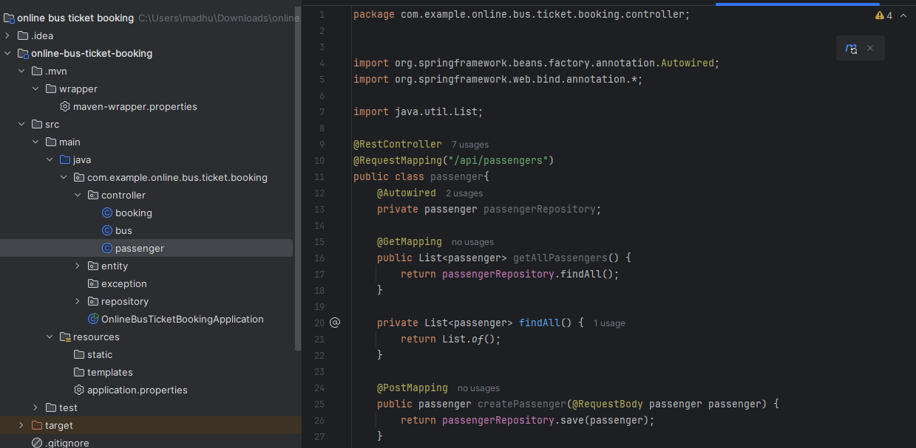

REPOSITORY-BOOKING

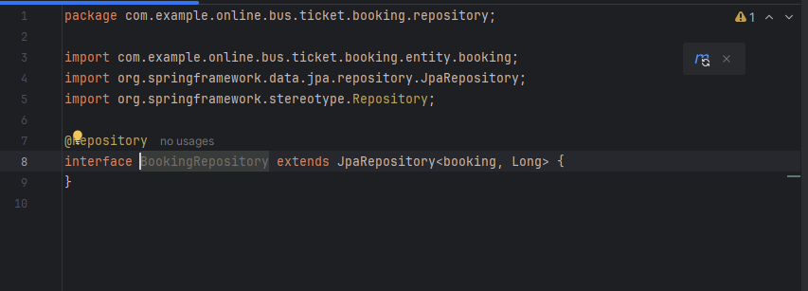

REPOSITORY-BUS



REPOSITORY-PASSENGER

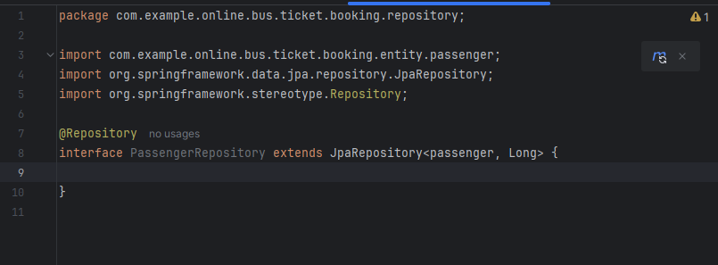

ONLINE BUS TICKET BOOKING APPLICATION

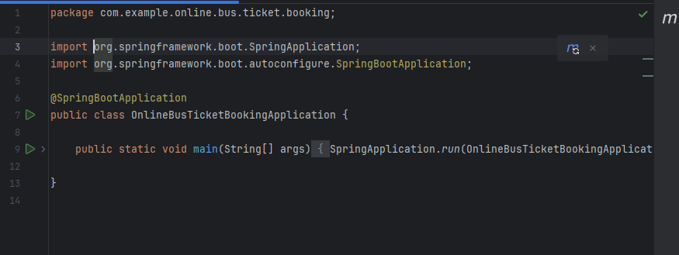

APPLICATION PROPERTIES

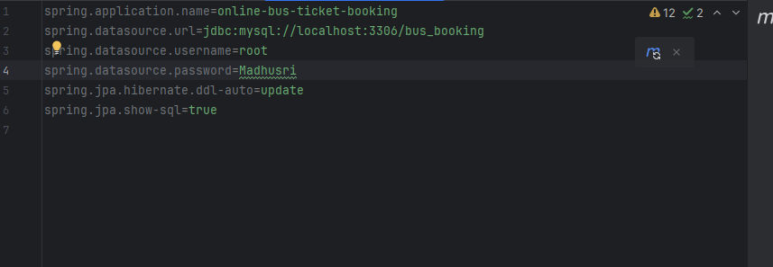

HTML files

